Name ________________________________ Date _______________________
NYS Homework #25 Class _______

- Which of the following types of quadrilaterals always has congruent sides?
  - Rhombus
  - Trapezoid
  - Rectangle
  - Parallelogram

- Mr. King needs to measure $\frac{3}{4}$ cup containers of water for each of his students for a science project. How many $\frac{3}{4}$cup containers can he fill from a 15-cup pitcher?
  - 11 ¼
  - $\frac{3}{60}$
  - 20
  - $\frac{1}{20}$

- Mrs. Mattack wants to put a paver path around her swimming pool. Installed paver paths cost $30 per foot. The dimensions of Mrs. Mattack's pool are shown in the diagram below.
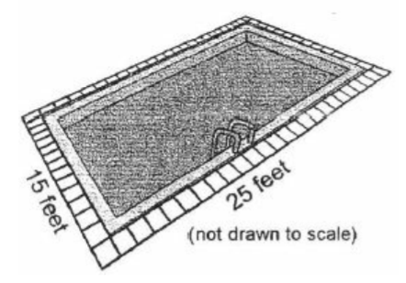
What is the cost of installing the paver path?
  - $2,400
  - $11,250
  - $1,200
  - $240

- At a picnic, 15 people shared 5 large sandwiches equally. How much of a did each person get to eat?
  - $\frac{15}{5}$of a sandwich
  - $\frac{1}{5}$ of a sandwich
  - $\frac{1}{3}$of a sandwich
  - 3 sandwiches
- The list below shows the numbers of miles John walked each day for 12 days.

4$\frac{3}{4}$ , 5 , 5$\frac{3}{4}$ , 4 $\frac{1}{2}$ , 4 $\frac{1}{4}$ , 4 $\frac{2}{4}$ , 5 , 4 , 5 $\frac{1}{4}$ , 5 , 4$\frac{3}{4}$ , 5$\frac{3}{4}$

Make a line plot of the data using the line below. Include a title and correct labels.

