Name ________________________________ Date ____________________
NYS Homework #24 Class _______

- Luis wants to make 1,000 burgers. Each burger requires five grams of meat. He has 4.25 kilograms of meat. Exactly how many more grams of meat does Luis still need to make 1,000 burgers?
  - 150
  - 100
  - 8.5
  - 850

- When dividing n ÷ ½ the quotient will be ______________.
  - twice the size of n
  - 2 greater than n
  - half the size of n
  - 3 times the size of n

- Ethan’s bed has a length of 250 centimeters. What is the length of Ethan’s desk in meters?
  - 2.5 centimeters
  - 0.25 meters
  - 2.5 meters
  - 25 meters

- Students in Mr. King’s Science class measured the height of pea plants to the nearest 1/3 inch. The result of these measurements are listed in the line plot below.
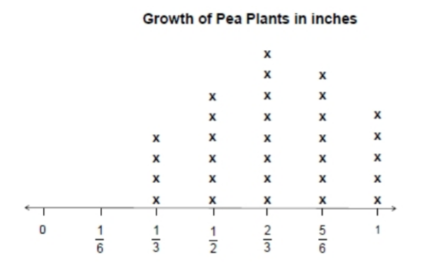
How many plants measured 2/6 and 2/3 combined?
- 8
- 12
- 20
- 18

- Aaron has 7.65 kilograms of berries. He packs 0.45 kilogram of berries into each container. He then sells each container for $1.99. How much money will Bella earn if he sells all the containers?
Show your work.

Answer ______________________

- Daniel buys 24 boxes of toothpicks for a school project. There are 230 toothpicks in each box. If 1/4 of the total toothpicks are broken, how many are not broken?

Solve.

Answer ______________________

