Name ________________________________ Date __________________
NYS Homework #23 Class ______

- Ellis has 5 ½ gallons of milk for a Fortnite party. He pours one pint of milk for every friend at the party. If Ellis uses all 5 ½ gallons, how many friends get milk?
  - 40
  - 44
  - 22
  - 80

- In a math game, a player chooses two numbers, as described below.
- First number: a mixed number between 1 ½ and 6 ½
- Second number: 10
Which statement describes the product of the two numbers a player chooses?
- The product must be a whole number less than the second number.
- The product must be a value greater than 10.
- The product must be a whole number greater than 10.
- The product must be a mixed number greater than 10.

- Kim, Lu, and Mia each ran part of a 8-mile relay race. The distance each girl ran is shown on the number line.
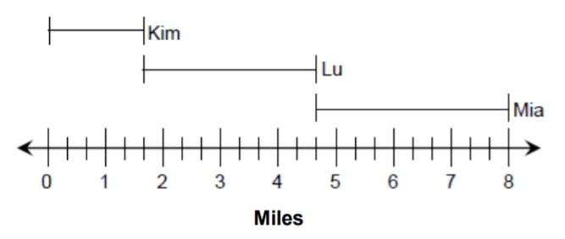
Which of these is the sum of the longest distance and the shortest distance the three girls ran?
- 4
- 5
- 1 $\frac{2}{3}$
- 1 $\frac{1}{3}$

- Tony Began putting together a rectangular puzzle. He completed the top edge and left edge puzzle, as shown below. Each piece is a square that has a side length of 1 ½ inches.
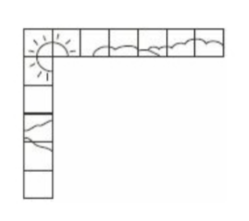
What is the total perimeter, in inches, of the completed puzzle?

Show your work.

Answer _____________________________ inches

